GitHub: Getting Started

Create Accounts

* Sign up for a **GitHub** account.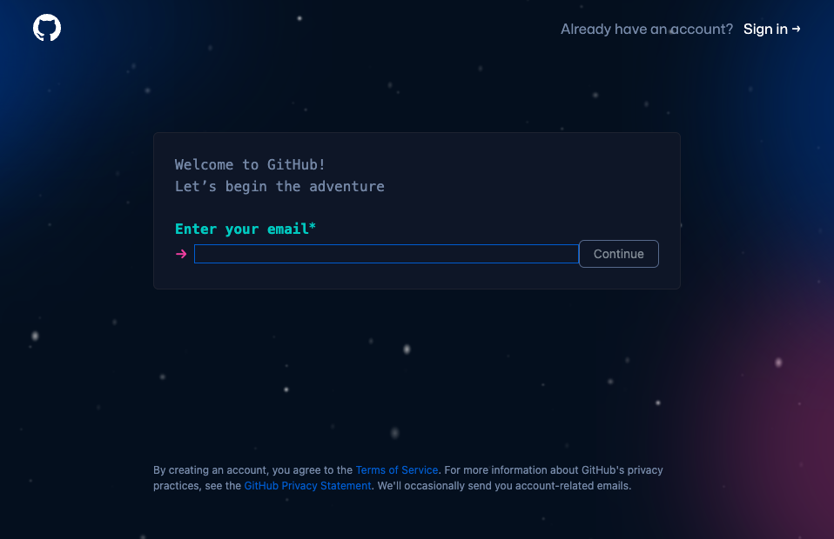
* Download the **GitHub Desktop** application and install it on your computer.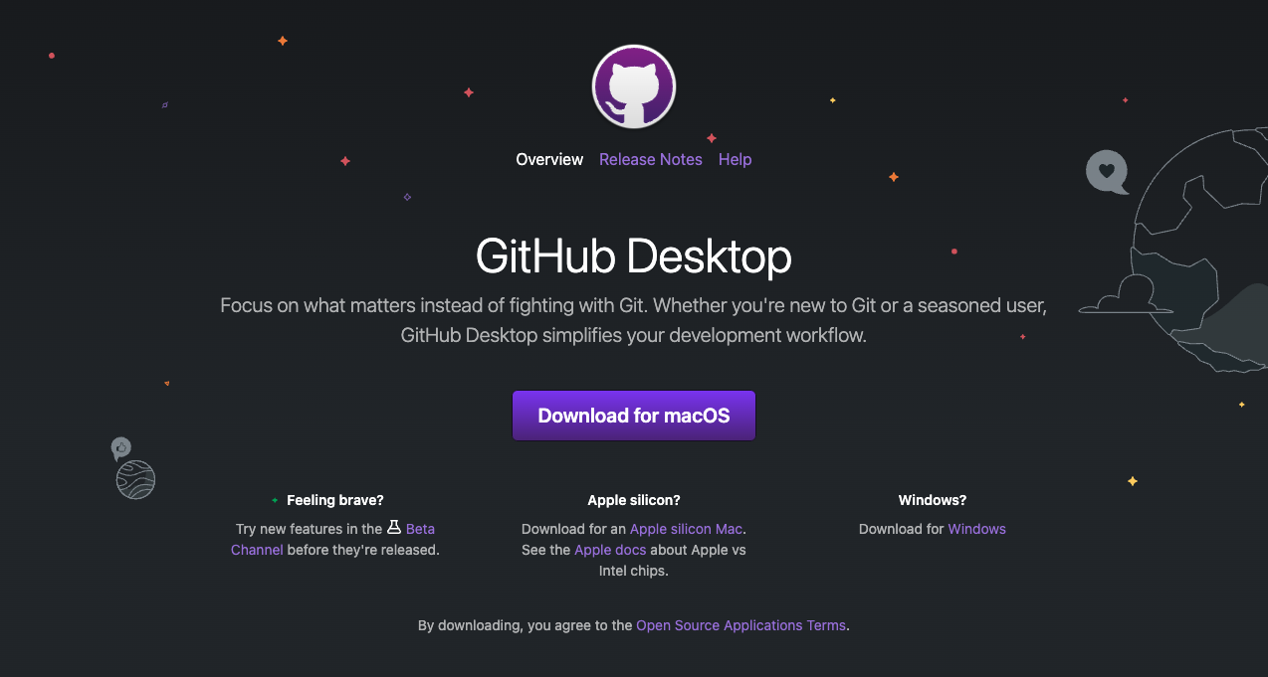

Create Repository

* Log into github.com and create a new repository (aka folder) using the link under the + icon in the upper right of the GitHub homepage. Note: This is the folder where you will be keeping all the projects and assignments for this course.

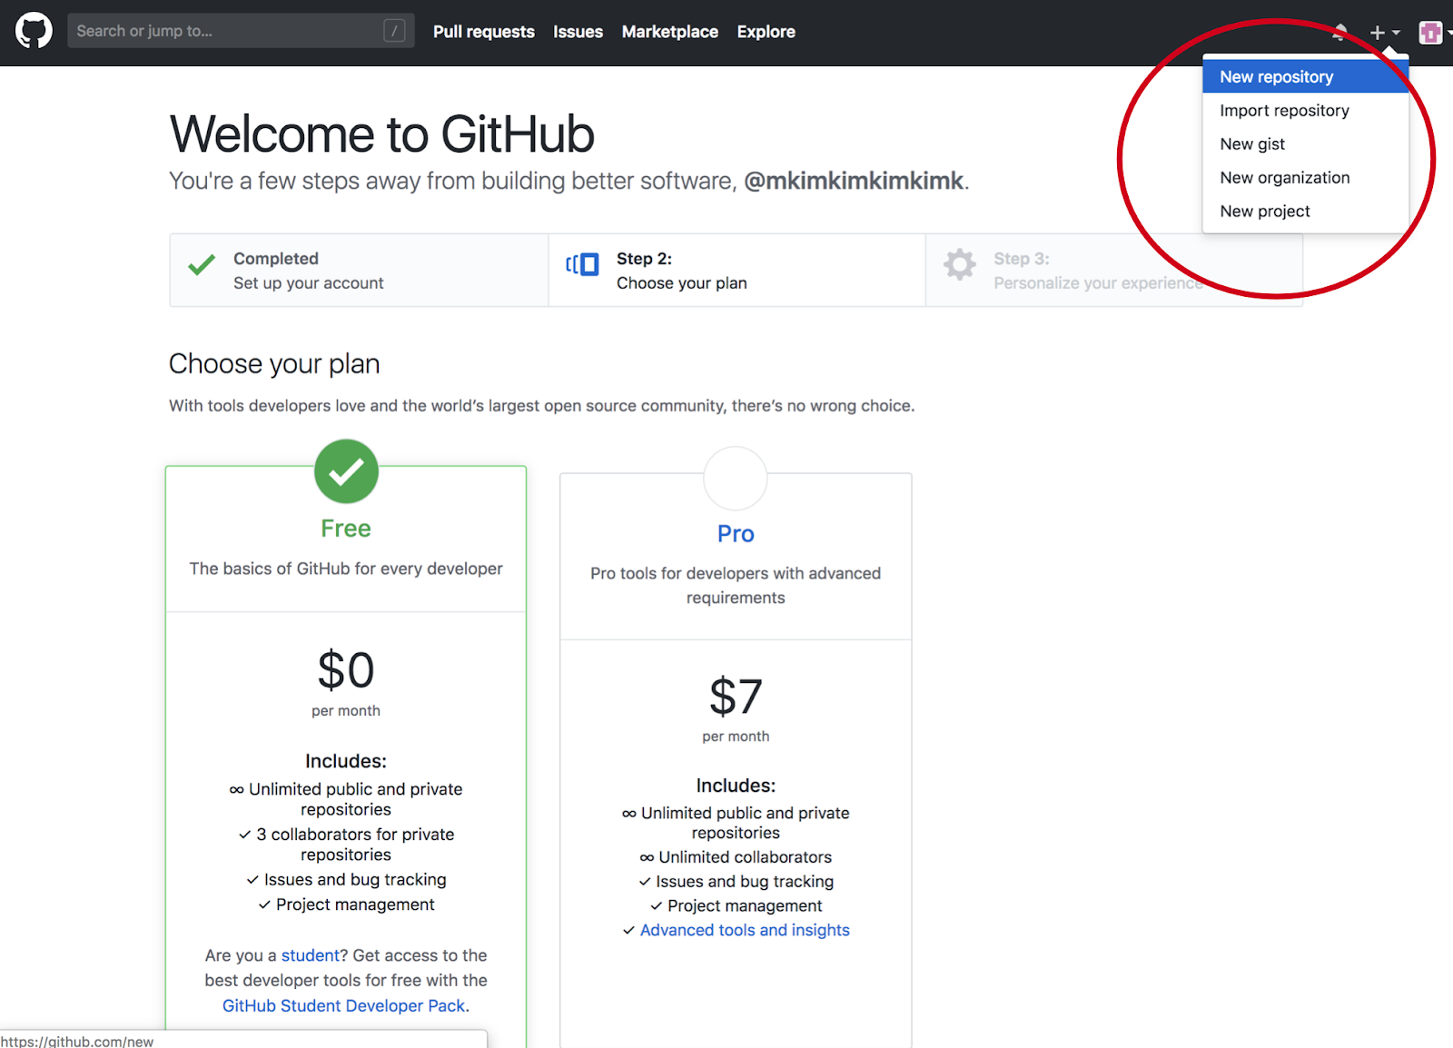

* Name the repository. For example, I named this one didactic-eureka. *Thanks for the recommendation, GitHub!* Check the box to add a README file. This repository will be the home for all your assignments and exercises for this class. Click the green create repository button.

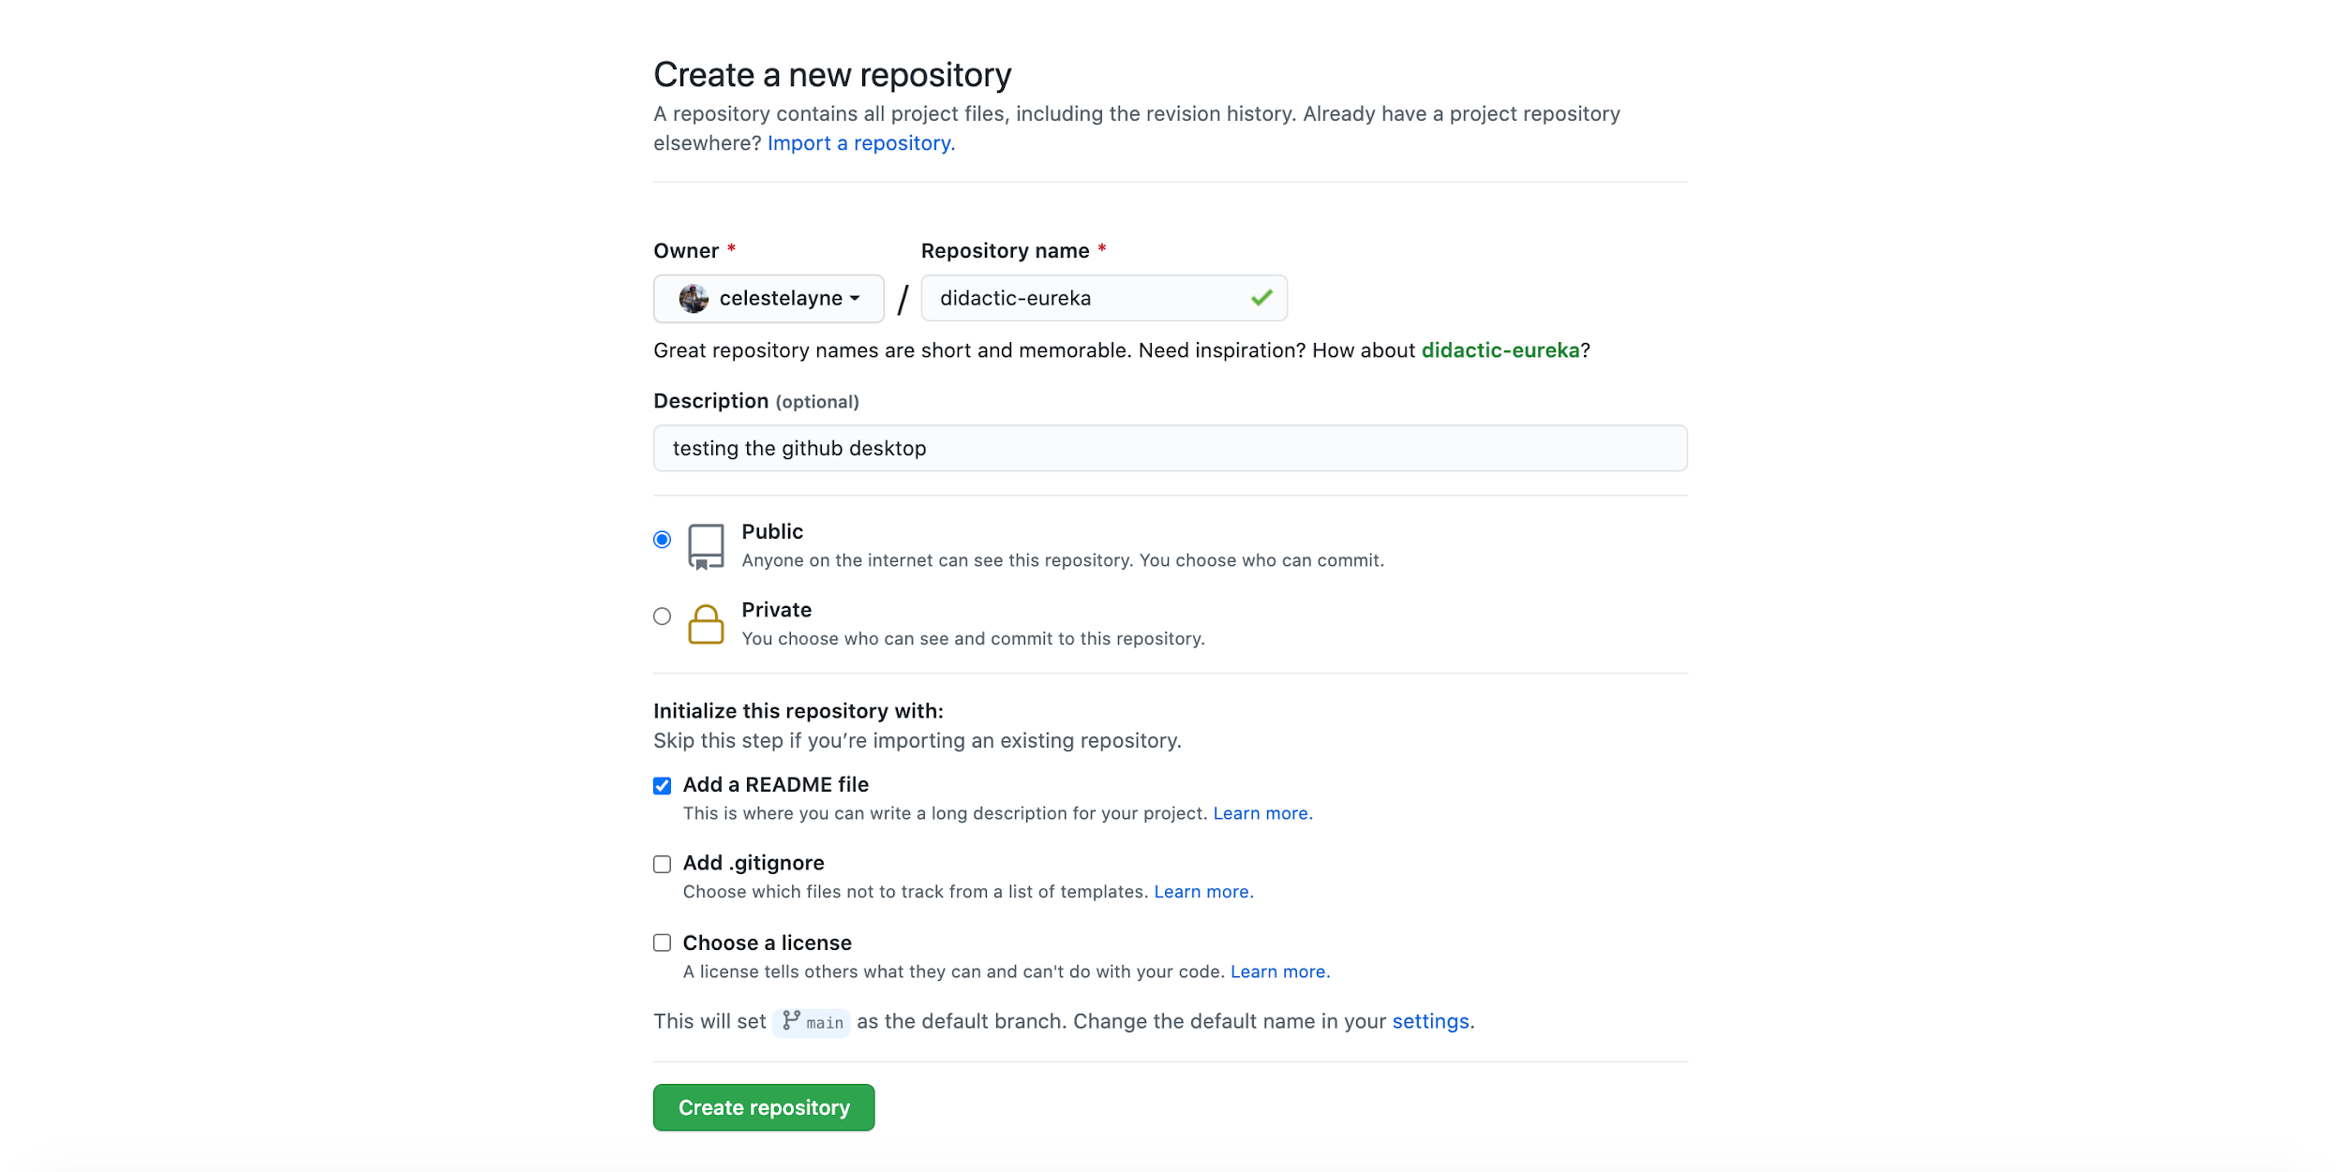

* Once you’ve initialized the repository, it will take you to the home screen. Click the green Code button. Then select, Open with GitHub Desktop.

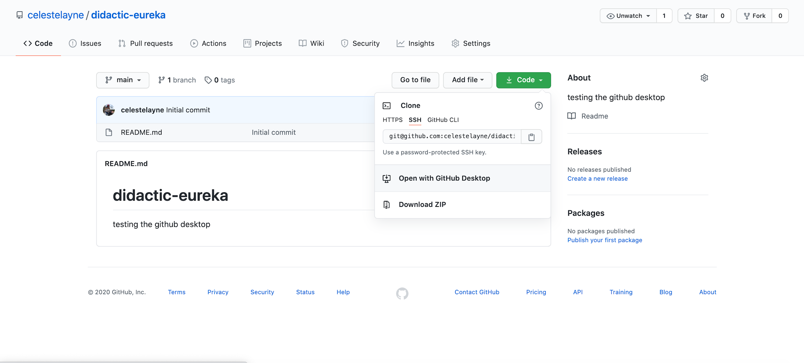

* When you press this button, you may see an alert window asking, Open GitHub Desktop? Click the Open GitHub Desktop button in the alert box. This will launch the GitHub Desktop application.

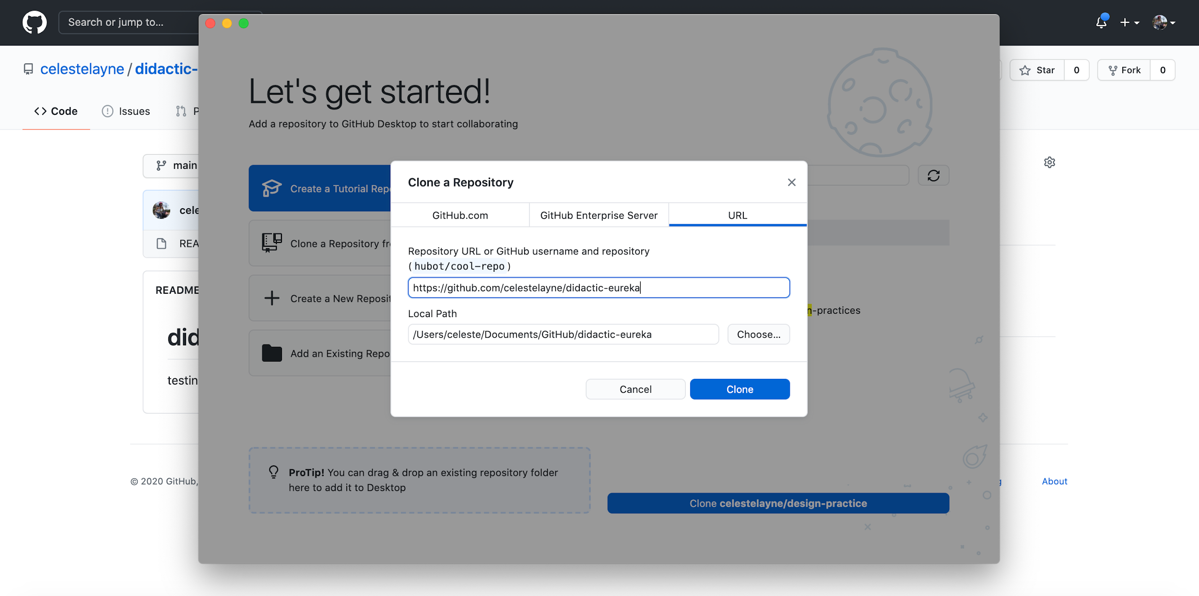

* Now…**( this is important )** choose a place on your computer where you want this repository to live. My local path is: /Users/celeste/Documents/GitHub/didactic-eureka. Click the blue Clone button.

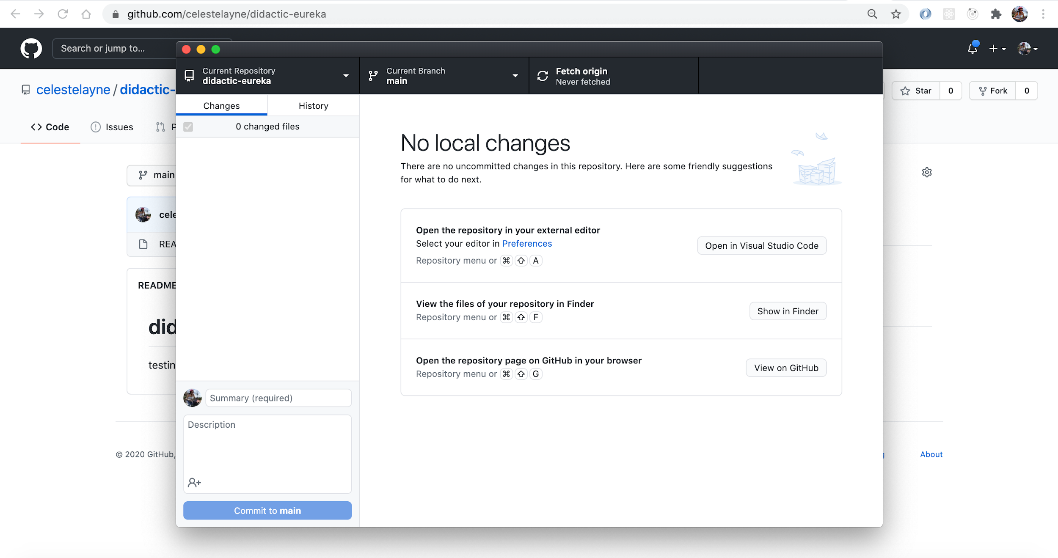

* *Yay!* You’re in your local repository. GitHub Desktop provides some friendly suggestions for where to go next:
  1. Open the repository in your code editor (Visual Studio Code)
  2. View the files in the Finder (Mac) or Explorer (Windows) app
  3. Open the repository page on GitHub in your web browser
* If you select, view the files in finder, you will be taken to a folder named ‘didactic-eureka’, this is the ‘local’ version of your github repository. Its local address is: /Users/celeste/Documents/GitHub/didactic-eureka. Through the course of this semester, we will use this as **the space** to do all your projects and exercises.

**Create Your First Webpage**

* Open the repository in your code editor
* Follow the instructions of *Exercise 1: Hello World* on the class website.

**Commit and Push your repository**

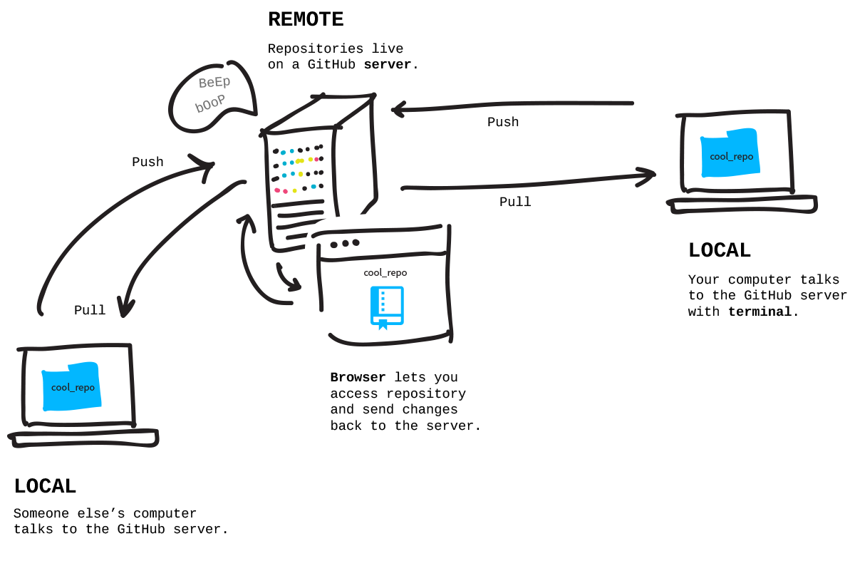

commit : add and save changes to the local repository

push : sending your committed changes to a remote repository, such as a repository. For instance, if you change something locally, you'd want to then push those changes so that others may access them.

* Confirm that you see changes made to your file in the Changes Tab on the GitHub Desktop app.

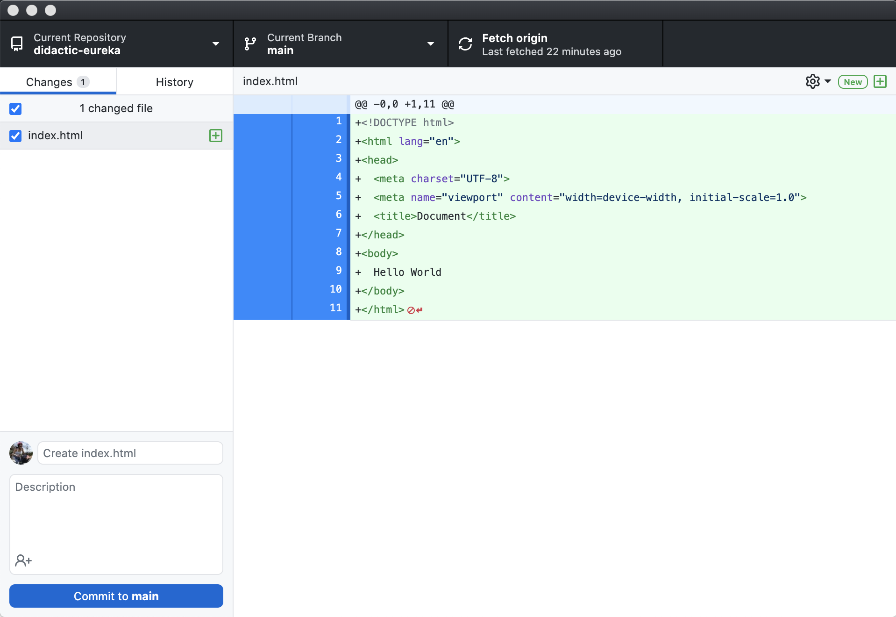

* Click the blue Commit to main button, then press Push to Origin.
* Now, check to make sure that your changes were pushed to the main github.com repository. Reload the page if you don’t yet see changes.

**Publish Your Website**

* In your github.com repository, find the Settings tab.
* Scroll to the GitHub Pages section. Select the main branch as your publishing source from the dropdown menu. Keep the /(root) folder for your publishing source.
* Click Save.
* *Now, drumroll please!* In the same GitHub Pages section, you should see: Your site is ready to be published at <https://celestelayne.github.io/didactic-eureka/>. Click the link. *Voila!*

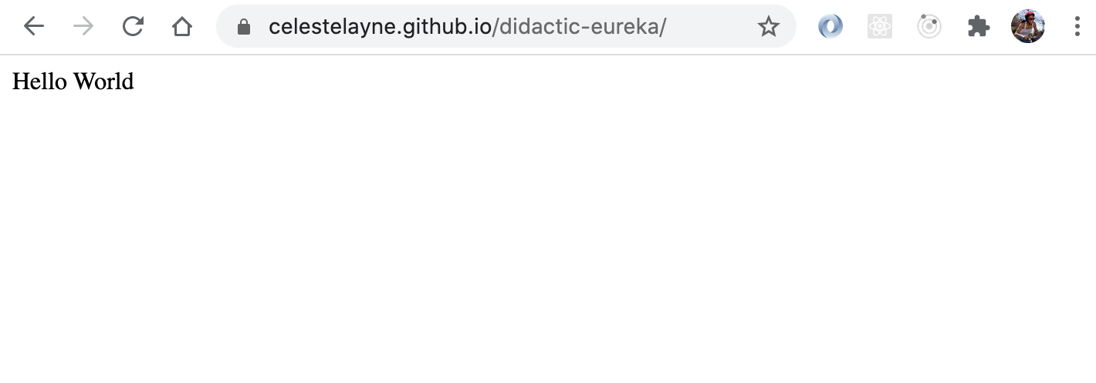

The end.